MIX USED, SENIOR HOUSING
Construction Phasing, Schedule & Cost Proposal
A Mixed-Use Senior Housing, Communal Housing & Retail Development
Market Street Corridor, Downtown Oakland, California

Project Data
Owner | The Senior Housing Group
Architect | MPA Design
General Contractor | Turner Construction
Total Gross Building Area (GBA) | 32,500 SF (FAR 4.0)
Building Height | 4 Stories
Anticipated Construction Start | September 3, 2027
Estimated Substantial Completion | February 2029 (~17-month duration)
Estimated Total Project Cost | $17,300,000 (± planning-level estimate)

Part 1 — Proposal

1.1 Project Overview
Mix Used, Senior Housing is a four-story mixed-use development on the Market Street corridor in Downtown Oakland, California, combining ground-floor boutique retail, senior housing, and communal (co-living) housing around a central courtyard. The building totals approximately 32,500 SF of gross building area at FAR 4.0, organized as a transparent retail plinth at grade with two residential wings above — senior housing to the east and communal housing to the west — stepping back at the upper floors to create planted terraces. The design emphasizes daylighting through a central courtyard void, a vertical circulation spine for wayfinding, and a materials palette of light concrete, fiber-cement panel, perforated metal shading, and warm wood accents.
This proposal presents a planning-level construction phasing plan, project schedule, and cost estimate for Owner review, together with a set of illustrative project-administration documents (Part 2) representative of the reporting the Owner should expect to receive once construction is underway.

1.2 Construction Phasing
Construction is organized into fourteen sequential and overlapping phases, proceeding from site mobilization through owner move-in:
- Mobilization & Site Logistics — Contractor mobilization, temporary utilities, site fencing/logistics plan, survey control. Site is assumed cleared per prior massing/entitlement studies.
- Excavation & Foundations — Excavation, shoring as required, spread/mat footings and foundation walls for podium structure.
- Podium / Structural Concrete (Ground Floor) — Ground-floor structural concrete slab and retail-level structure supporting residential wings above.
- Vertical Structural Framing (Levels 2–4) — Wood-frame structure for senior housing and communal housing wings over the concrete podium.
- Building Envelope & Exterior Enclosure — Weather-resistive barrier, high-performance glazing, fiber-cement/concrete panel cladding, and perforated metal shading fins.
- MEP Rough-In (All Levels) — Electrical, plumbing, low-voltage, and HVAC rough-in throughout residential and retail levels.
- Retail Shell & Core / TI Coordination — Delivery of retail spaces as vanilla shell with coordination allowances for future tenant improvements.
- Interior Build-Out – Senior Housing Wing — Partitions, finishes, casework, and accessibility-compliant fixtures in the senior housing wing.
- Interior Build-Out – Communal Housing Wing — Partitions, finishes, and shared/communal-living amenity spaces in the west wing.
- Courtyard, Terraces & Landscape — Central courtyard hardscape/softscape, planted terrace waterproofing and planting, site lighting.
- Finishes, Fixtures & Equipment (FF&E) — Flooring, paint, lighting fixtures, appliances, and furnishing of common areas.
- Testing, Commissioning & Inspections — MEP systems testing/balancing, life-safety systems commissioning, City inspections.
- Punch List & Certificate of Occupancy — Deficiency correction, final walkthroughs, and Certificate of Occupancy issuance.
- Owner Move-In / Project Closeout — Owner move-in coordination, as-built documentation, warranty turnover, project closeout.

1.3 Project Schedule
Schedule Estimating Methodology: In the absence of a detailed CPM network, the overall project duration was estimated using a planning-level production rate of approximately 2,500 SF of gross building area per month for a wood-frame-over-concrete-podium mixed-use building of this scale and complexity (32,500 SF ÷ 2,500 SF/month ≈ 13 months baseline). A 30% schedule contingency was then added to account for permitting variability, inspection cycles, weather (notably the Bay Area wet season), and construction-market supply/labor conditions (13 months × 1.30 ≈ 17 months). This yields an estimated overall duration of 17 months from a September 3, 2027 start to an estimated substantial completion in February 2029.
# | Phase | Approx. Start | Approx. End | Duration (mo.)
1 | Mobilization & Site Logistics | Sept 2027 | Sept 2027 | 0.5
2 | Excavation & Foundations | Sept 2027 | Nov 2027 | 2.0
3 | Podium / Structural Concrete (Ground Fl.) | Nov 2027 | Jan 2028 | 2.5
4 | Vertical Structural Framing (Levels 2-4) | Jan 2028 | Apr 2028 | 3.5
5 | Building Envelope & Exterior Enclosure | Mar 2028 | Jul 2028 | 3.5
6 | MEP Rough-In (All Levels) | Mar 2028 | Jul 2028 | 4.5
7 | Retail Shell & Core / TI Coordination | Apr 2028 | Jun 2028 | 2.5
8 | Interior Build-Out – Senior Housing Wing | May 2028 | Sept 2028 | 3.5
9 | Interior Build-Out – Communal Housing Wing | Jun 2028 | Sept 2028 | 3.5
10 | Courtyard, Terraces & Landscape | Jul 2028 | Oct 2028 | 3.0
11 | Finishes, Fixtures & Equipment (FF&E) | Aug 2028 | Nov 2028 | 3.0
12 | Testing, Commissioning & Inspections | Nov 2028 | Jan 2029 | 2.0
13 | Punch List & Certificate of Occupancy | Dec 2028 | Jan 2029 | 1.0
14 | Owner Move-In / Project Closeout | Jan 2029 | Feb 2029 | 0.5

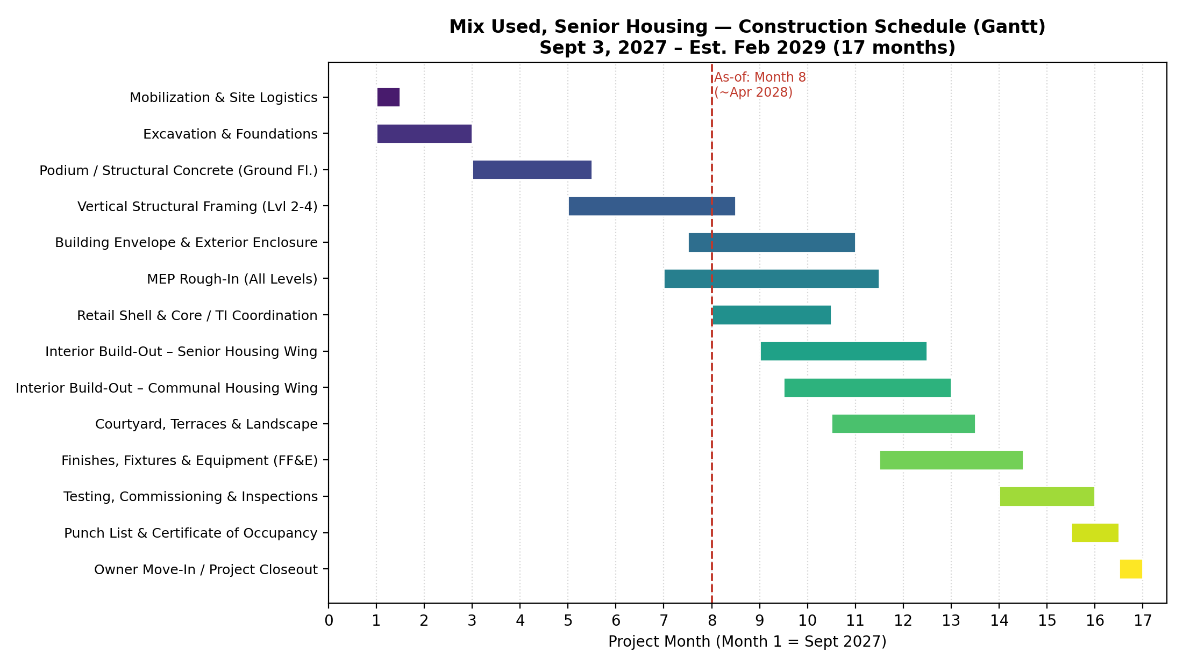
Figure 1: Construction schedule Gantt chart, Month 1 = September 2027. The dashed line marks Month 8 (~April 2028), the illustrative "as-of" status date used for the Part 2 project-administration documents.

1.4 Cost Estimate
Cost Estimating Methodology: Hard construction costs were estimated by applying planning-level unit costs ($/SF) to each program component's area, differentiated by use type to reflect relative finish level and building-system intensity (e.g., senior housing carries a higher $/SF than a retail vanilla shell). Consistent with the schedule contingency above, a 30% allowance was then added on top of the base hard-cost subtotal to cover design contingency, escalation to a 2027–2028 start, and general conditions/fee — appropriate for this early planning stage in advance of a detailed GC estimate or subcontractor buyout.
Program Component | Area (SF) | % of GBA | $/SF |  | Estimated Cost
Retail – Ground Floor | 6,500 | 20% | $350 |  | $2,275,000
Lobby / Core | 3,250 | 10% | $450 |  | $1,462,500
Service / Back-of-House | 1,625 | 5% | $300 |  | $487,500
Senior Housing | 9,750 | 30% | $460 |  | $4,485,000
Communal Housing | 9,750 | 30% | $430 |  | $4,192,500
Planted Terrace / Landscape | 1,625 | 5% | $250 |  | $406,250
Total GBA |  |  |  | 32,500 SF
Base Hard Construction Cost Subtotal |  |  |  | $13,308,750
Contingency / Escalation / GC Fee Allowance (+30%) |  |  |  | $3,992,625
Estimated Total Project Cost |  |  |  | $17,301,375
Estimated Cost per SF (all-in) |  |  |  | ≈ $532 / SF
Note: These figures are planning-level, order-of-magnitude estimates prepared for an academic/illustrative proposal. They are not a Contractor bid or a substitute for a detailed quantity take-off, geotechnical/structural analysis, or current Bay Area bid-market pricing, all of which should be obtained before this estimate is relied upon for financing or entitlement purposes.

Part 2 — Project Administration Documents
Construction has not yet begun as of this proposal (anticipated start: September 3, 2027). The four documents below are illustrative examples, prepared as if the project were at Month 8 of the 17-month schedule (approximately April 2028) — a representative mid-construction milestone at which vertical framing is substantially complete and building envelope and MEP rough-in are underway (see Figure 1). Project names, dates, and field conditions are representative rather than actual field-verified data.

2.1 Site Observation Report
Field | Detail
Report No. | SOR-008
Date | April 10, 2028
Project | Mix Used, Senior Housing — Market Street Corridor, Downtown Oakland, CA
Weather / Site Conditions | Partly cloudy, 58°F, light wind — no weather-related delays
Personnel Present | Site Superintendent (Turner Construction); Project Architect representative (MPA Design); Owner's Representative (The Senior Housing Group)
Observations: Vertical structural framing at Levels 3–4 is substantially complete; the framing crew is mobilizing to Level 4 parapet and roof blocking. The building envelope subcontractor is installing the weather-resistive barrier and beginning perforated-metal shading-fin brackets at the south (retail) façade. MEP rough-in is progressing at Levels 2–3 (electrical conduit, plumbing DWV stacks). Retail-level slab-on-grade patching at the storefront line is complete.
Quality / Safety: Fall-protection guardrail at the Level 4 terrace edge (west wing) was not yet installed at the time of the walk; flagged to the GC superintendent for same-day correction. No other safety non-conformances observed. Framing tolerances spot-checked at grid lines 4–7 were within allowable tolerance.
Photos Referenced: Photo 1 — Level 4 framing, west wing. Photo 2 — WRB installation, south façade. Photo 3 — MEP rough-in, Level 2 corridor. Photo 4 — guardrail gap, Level 4 terrace edge.
Action Items: (1) GC to install missing guardrail at Level 4 terrace edge by end of day. (2) Confirm root-barrier/waterproofing detail per RFI-014 prior to terrace slab topping pour. (3) Schedule envelope mock-up review for the perforated metal screen fastening pattern.

2.2 RFI Response
Field | Detail
RFI No. | RFI-014
Date Submitted | April 8, 2028
Date Responded | April 15, 2028
Subject | Waterproofing & drainage detail at Level 2 planted terrace over occupied lobby below
Originator | Turner Construction (GC), on behalf of waterproofing/landscape subcontractor
Respondent | MPA Design (Architect of Record)
Question: Drawings A-501 and L-201 appear to conflict between the specified two-ply hot-applied waterproofing membrane detail and the root-barrier/drainage-mat assembly at the planted-terrace slab edge where it meets the glass lobby curtain wall below (Detail 4/A-502). Please clarify correct sequencing and termination, and confirm compatibility of the specified root barrier with the structural waterproofing warranty.
Response: Sequence from structural slab outward is as follows: (1) structural concrete slab; (2) two-ply hot-applied waterproofing membrane, turned up a minimum of 8 inches at the parapet/curtain-wall interface and terminated behind the curtain-wall sill flashing; (3) protection board; (4) drainage mat; (5) filter fabric; (6) growing medium. The root barrier shall extend a minimum of 12 inches beyond the planter edge and turn up behind the sill flashing to match the waterproofing termination. Root barrier and waterproofing membrane shall be sourced from the same manufacturer's approved system list to preserve the 20-year manufacturer warranty. A revised detail will be issued via ASI/Bulletin 006 for incorporation into the subcontractor's shop drawings.
Schedule Impact: None, provided the revised submittal is approved within 5 business days of ASI issuance.
Cost Impact: None — revised sequencing/detail only; no change in scope or material quantities.

2.3 Construction Progress Summary
Field | Detail
Reporting Period | March 26 – April 25, 2028 (Month 8 of 17)
Overall Schedule Elapsed | 8 of 17 months (47%)
Overall Physical Completion (est.) | ≈ 42%
Cumulative Spend to Date | ≈ $7.1M of $17.3M (≈ 41%)
Percent Complete by Phase:
Phase | % Complete
Mobilization & Site Logistics | 100%
Excavation & Foundations | 100%
Podium / Structural Concrete | 100%
Vertical Structural Framing | 85%
Building Envelope & Exterior Enclosure | 15%
MEP Rough-In | 20%
Retail Shell & Core / TI Coordination | 5%
Interior Build-Out (both wings) | 0%
Courtyard, Terraces & Landscape | 0%
Finishes, Fixtures & Equipment | 0%
Testing, Commissioning, Closeout | 0%
Milestones Achieved This Period: Vertical structural framing substantially topped out (Level 4 complete); building envelope installation started at the south façade; MEP rough-in underway at Levels 2–3; RFI-014 (terrace waterproofing detail) resolved with no schedule or cost impact.
Schedule Status: On track. Physical completion (≈42%) is tracking consistently with schedule elapsed (47%), reflecting the normal early-phase weighting toward structure and shell; no float has been consumed on the critical path.
Budget Status: On track. Cumulative spend (≈41%) is consistent with physical progress and the approved cost estimate; no change orders issued to date.
Issues / Blockers: Minor safety corrective action (missing guardrail) identified and closed same day (see Site Observation Report SOR-008). Awaiting subcontractor submittal approval on the root-barrier system tied to RFI-014.
Planned for Next Period: Complete building envelope on south and east elevations; complete MEP rough-in at Level 4; begin retail TI coordination meetings with GC; begin interior framing and rough-in inspections in the senior housing wing.

2.4 Risk Log
ID | Description | Category | Likel. | Impact | Mitigation Strategy | Owner | Status
R-01 | Long-lead fabrication of custom perforated metal shading fins | Schedule | Medium | High | Release fabrication 4 weeks ahead of need date; qualify a backup fabricator | GC (Turner) | Monitoring
R-02 | Waterproofing/drainage detail conflicts at planted terraces over occupied space | Quality | Medium | Medium | Standardize detail per RFI-014 resolution; require pre-installation mock-up | Architect (MPA Design) | Open
R-03 | Wet-season delays to envelope and landscape work (Nov–Mar) | Weather | High | Medium | Sequence envelope dry-in ahead of rainy season; temporary weather protection | GC (Turner) | Monitoring
R-04 | Senior housing accessibility compliance (Title 24 / ADA / FHA) in framing & rough-in | Compliance | Low | High | Third-party accessibility review at framing and rough-in milestones | Architect / Owner | Open
R-05 | Retail tenant improvement scope undefined (tenants not yet signed) | Cost / Schedule | High | Medium | Deliver vanilla shell; carry TI allowance; coordinate flexible utility stub-outs | Owner | Monitoring
R-06 | Construction cost escalation / material price volatility (steel, glazing) | Cost | Medium | High | Early procurement of glazing and structural steel; 30% contingency held | Owner / GC | Monitoring
R-07 | Subcontractor & skilled-labor availability amid regional multifamily volume | Schedule | Medium | Medium | Early subcontractor buyout; confirmed manpower commitments at key trades | GC (Turner) | Monitoring
R-08 | City of Oakland plan-check / inspection turnaround delays | Regulatory / Schedule | Medium | Medium | Pre-application meetings; expedited plan check where available; schedule float | Owner / Architect | Monitoring

